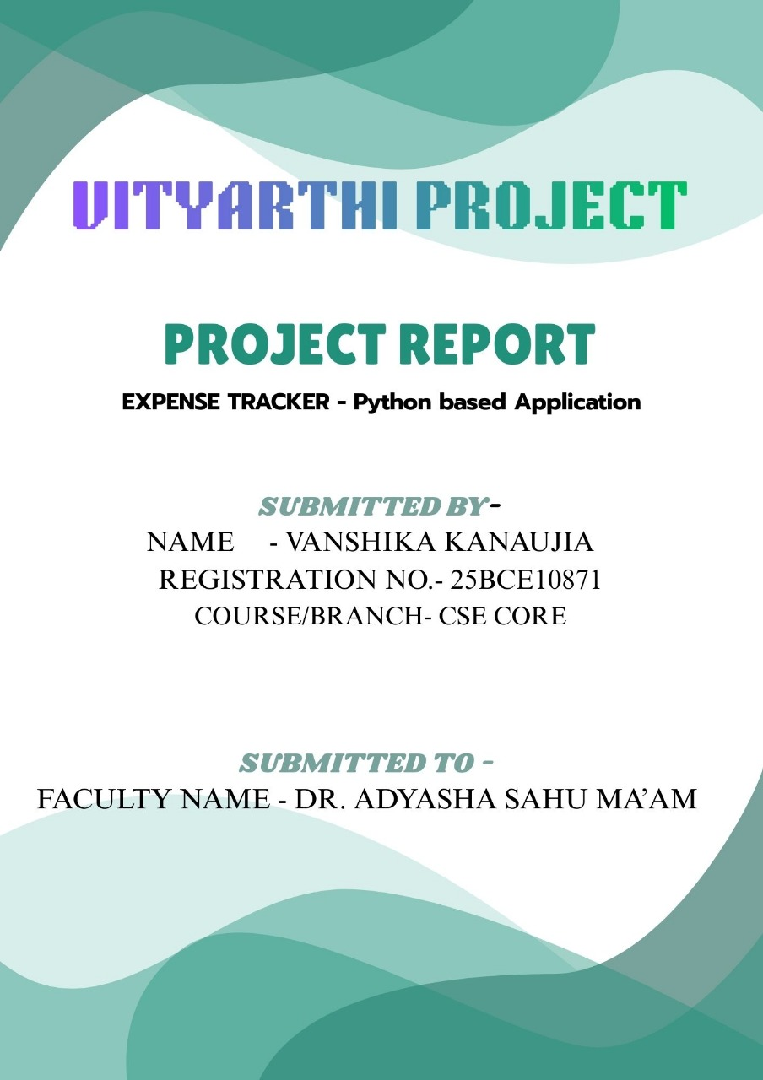
INTRODUCTION
The Expense Tracker is a straightforward application developed in Python, which aims to help users track their daily expenses. Budgeting is difficult and often people forget where their money went, and keeping a log becomes cumbersome. This project provides a digital solution that allows users to record their expenses, assign them a category, view expenses history, and see totals for the month with ease. This project uses a CSV file for data storage, which keeps it lightweight and able to run on any system.

OBJECTIVE
The main idea behind making this project was:
• to keep track of daily spending
• to learn how Python handles files and data
• to build something simple but actually helpful
• and to have a small project ready to upload on GitHub
I wanted it to be simple enough to use quickly but organised enough to show my expenses properly.

SCOPE
This project is a basic budgeting tool, not an advanced, full-featured budgeting app. The focus for this project will only be on the following basic functions:
• Add expenses
• See the expense history
• Filter expenses by category
• Delete expenses
• Show total expenses in a month

The application runs in the terminal (no GUI [graphic user interface] has been created yet). All data is in one CSV file. It is primarily for personal, student-level use.

PROBLEM STATEMENT
Most of us don’t keep track of our expenses. We remember big payments but forget small things like snacks, autos, online payments, etc. Over time these become a mess.
The problem was to create a small tool that can store these expenses in a clean way, without needing any fancy apps or internet connections. Something anyone could run on their laptop and quickly note down daily expenses.

FUNCTIONAL REQUIREMENTS
1. Add Expense: The user can enter the amount spent, the expense category and a brief description.
2. Viewing Expenses: All submitted expenses will be shown in an easily readable table format.
3. Delete Expense: The user will be able to delete an entry by expense ID (if they know it).
4. Filtering by Category: The user can view entries classified as whatever category they select - i.e. see my "Food" expenses.
5. Monthly Total: The user will be able to calculate their total expenses for any month.
6. Persistent Storeage: The user will have a file in CSV format called expenses.csv that contains all of their data.

NON-FUNCTIONAL REQUIREMENTS
Usability: The application should be simple and straight forward so anybody can operate it from the terminal.
Performance: The application needs to utilize internal/existing libraries to support efficient multi-entry expense entries.
Reliability: The data used to store expense entries will remain intact after the user closes the application.
Security: The expenses.csv file is local and should be safe to protect from outside users or access, but the file STAYS UNENCRYPTED.
Portability: The application will work on any device utilizing python - Windows, Mac, Linux.
Maintainability: The application code has been written in modular functions so that future changes are easier to support and maintain.

SYSTEM ARCHITECTURE
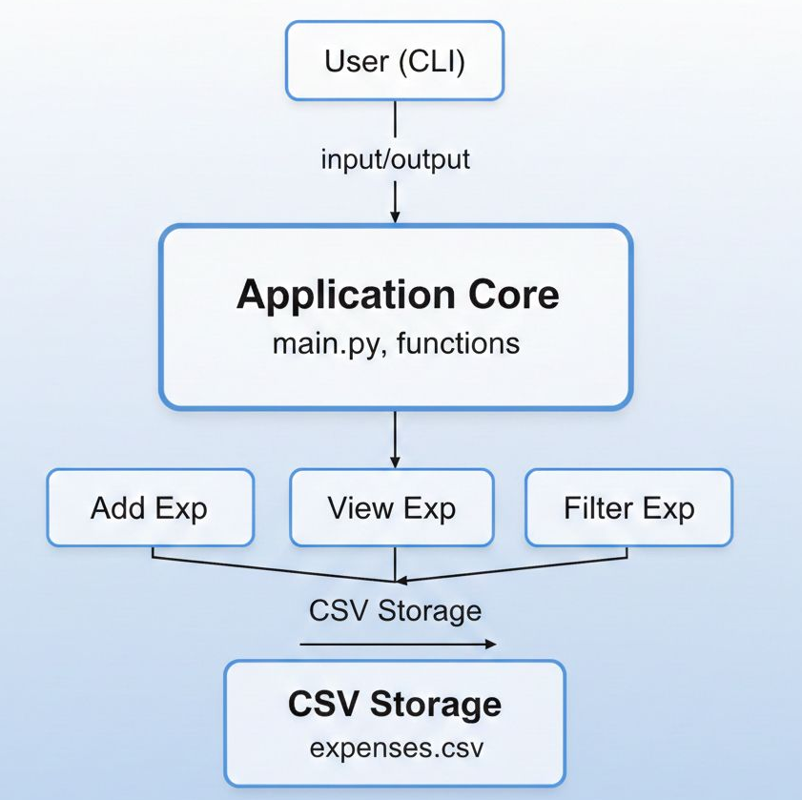

DESIGN DIAGRAMS
(A) Use case diagram
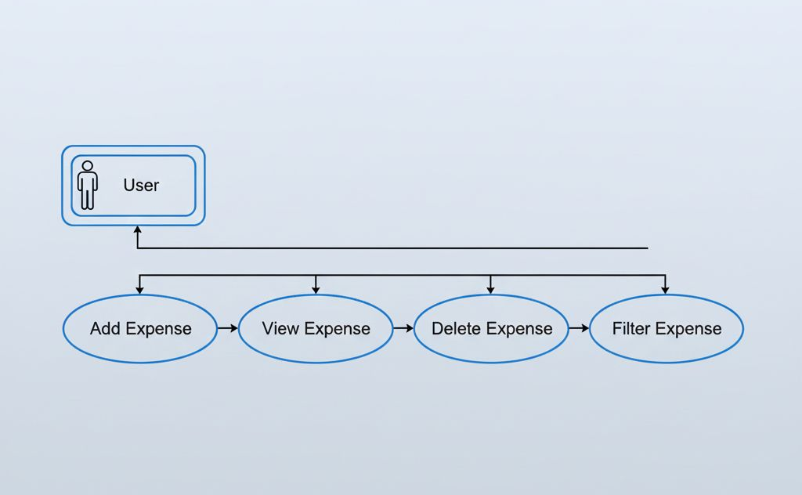
(B) Workflow diagram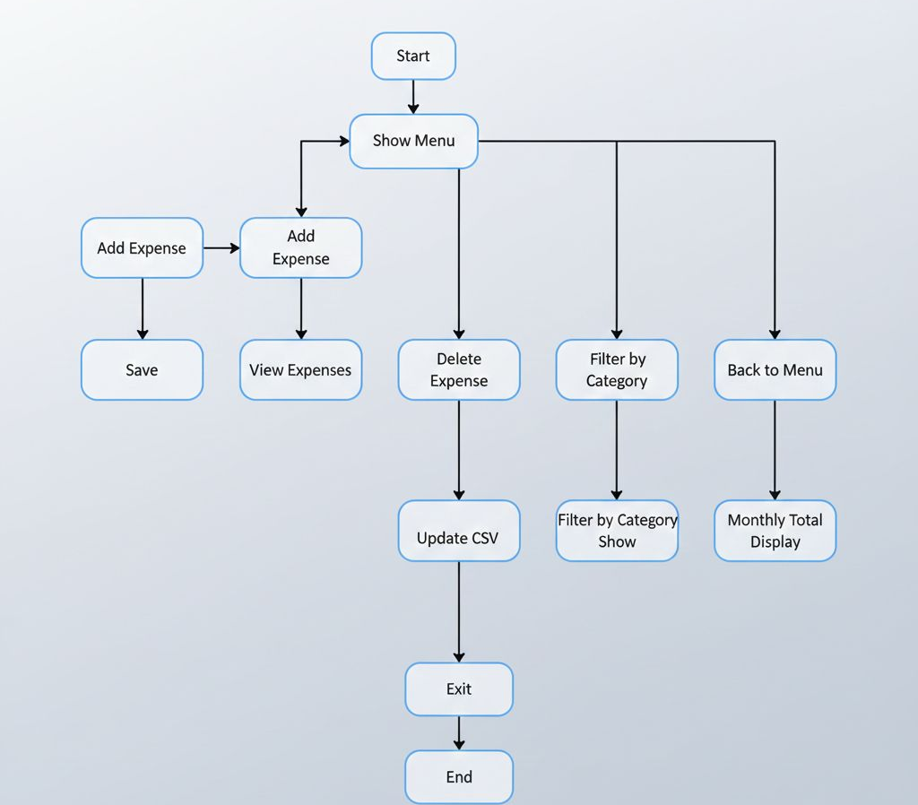
(C) Class / Component Diagram
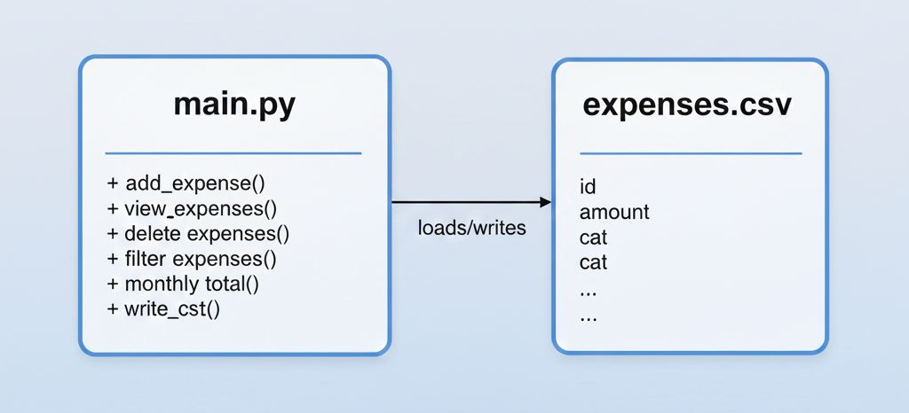

IMPLEMENTATION DETAILS.
• Python 3 – Programming language.
• CSV Module – For storing and reading expenses.
• Datetime Module – Used to automatically document an expense date.
• Git & GitHub – Used for version control and project sharing.
• Command Line Terminal – Used to execute and test program.

SCREENSHOTS/RESULTS
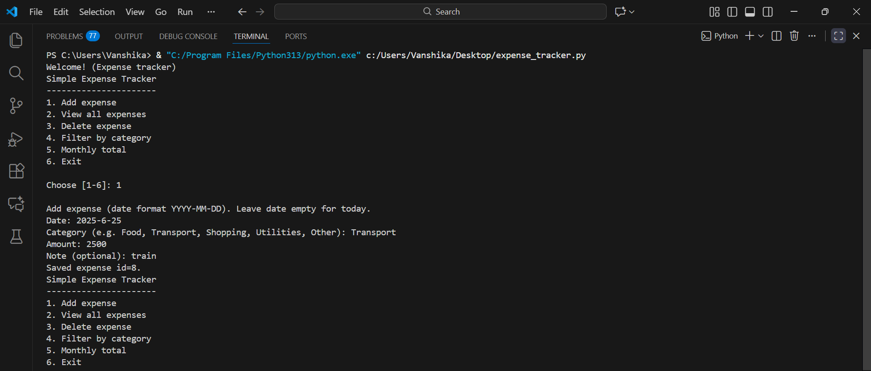
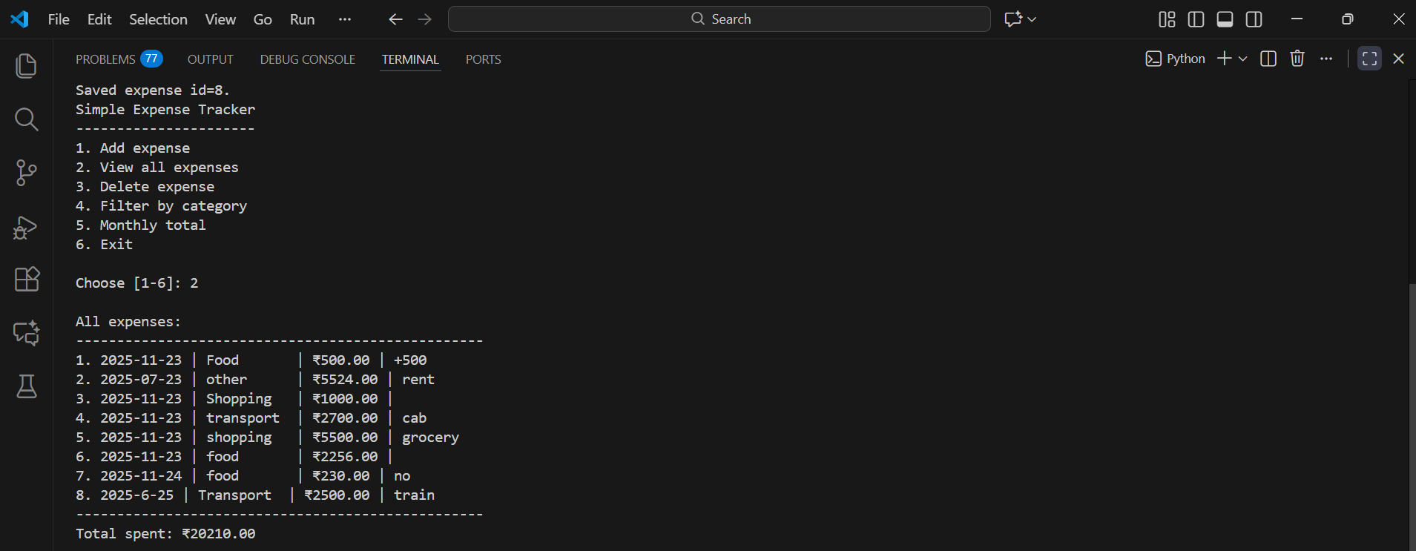
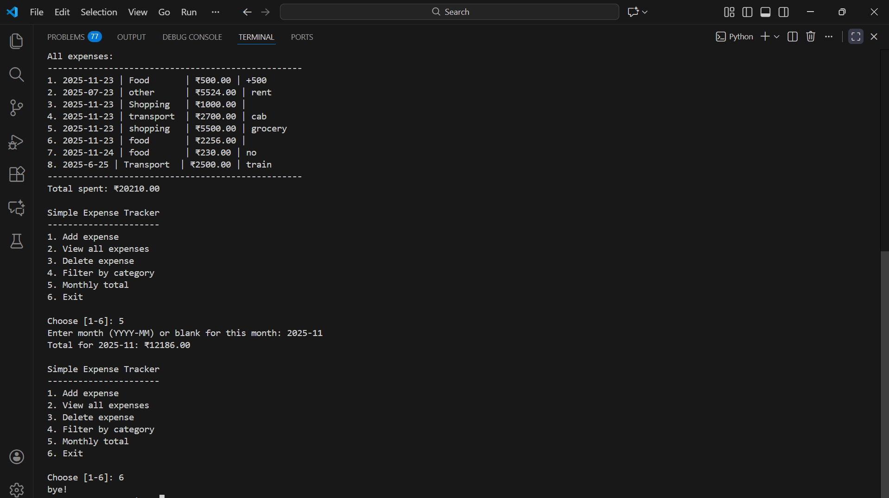

DESIGN DECISIONS AND RATIONALE
1. Using CSV instead of a Database
* The Decision: The code stores data in a simple text file (expenses.csv) rather than using a database like SQL or MongoDB.
* The Rationale: This keeps the project lightweight. You don’t need to install any extra software or run a local server to make it work. It also means you can double-click the file to open your data in Excel or Google Sheets if you want to manually fix a typo or make a chart, which is very convenient for a personal tool.

2. The "Dictionary" Approach
* The Decision: The code uses csv.DictReader and csv.DictWriter instead of standard list-based reading.
* The Rationale: This makes the code much easier to read and maintain. Instead of remembering that the "Amount" is in column 3 (e.g., row[3]), the code lets you access it by name (e.g., row["amount"]). This prevents bugs; if you decide to swap the order of columns later, the code won't break because it looks for labels, not positions.

3. The "Read-Modify-Write" Loop
* The Decision: Whenever you add an expense, the program reads all existing expenses into memory, adds the new one to the list, and then overwrites the entire CSV file.
* The Rationale: While this would be too slow for a simplified system with millions of users, it is the easiest way to handle a personal script with a few thousand entries. It simplifies the logic significantly because you don't have to worry about appending to the end of a file or managing file cursors—you just treat the data like a list in Python, modify it, and save.

4. Defensive Input Handling (User Proofing)
* The Decision: The code is designed to "fail safely." If a user enters a nonsense date (like "Tomorrow") or a bad amount (like "ten bucks"), the code defaults to today's date or 0.0 instead of crashing with an error message.
* The Rationale: This improves the user experience. It is frustrating to type out an expense entry only to have the program crash because of a typo. By using default values, the program keeps running, and the user can simply edit the entry later (or in the CSV directly).
* 5. Auto-Incrementing IDs
* The Decision: The script calculates a new ID by finding the highest existing ID and adding 1.
* The Rationale: Every database needs a "primary key"—a unique way to identify a row. Even though this is a simple CSV script, giving every expense a unique number (id) is smart planning. If you later add a feature to "Delete an Expense," you can tell the program to "Delete ID #5" rather than trying to search for "Lunch" and accidentally deleting the wrong row.

6. Standard Libraries Only
* The Decision: The code only imports csv, os, and datetime.
* The Rationale: These are built into Python. This means the script is highly portable; you can send this file to anyone with Python installed, and it will run immediately without them needing to use pip install to download external packages.
TESTING APPROACH
- Conducted a number of random expense tests.
- Verified that data was exported to CSV format correctly.
- Confirmed that the delete function is designed to delete only the specified ID.
- Verified that filtering would work for every option.
- Conducted boundary testing (null input, invalid IDs).
- Tested on multiple devices.

CHALLENGES FACED.
• No GUI, only CLI-based.
• No data encryption in storing expense information.
• No charts/graphs in this version.
• Cannot sync between devices, source data remains on local server.

LEARNING AND KEY TAKEAWAYS
- Gained experience with basic python file manipulation.
- Learned about how to create a menu driven CLI program.
- Learned about CSV formatting for data storage.
- Improved debugging and testing skills.
- Learned to design a small project in order to display it on Github.

FUTURE ENHANCEMENTS
• Use a graphing mechanism (Tkinter or PyQt) for a GUI.
• Include charts or graphs for insights into monthly spending.
• Add the ability to export (PDF, Excel).
• Incorporate a login system to include multiple users.
• Set up automatic budget warnings and alerts.

CONCLUSION
The Expense Tracker project fulfills its objective of providing a simple tool to track daily expenses. It shows how to use file handling in Python, functions, and menu driven programming. It is easy to use, light weight and suitable for academic assignments. In the future it can be enhanced with additional features and become a more serious budgeting software.

REFERENCES
(a) Class notes and material.
(b)GitHub examples of beginner Python projects.

